15. EVALUATING THE ACCURACY OF THE CLASSIFIERS

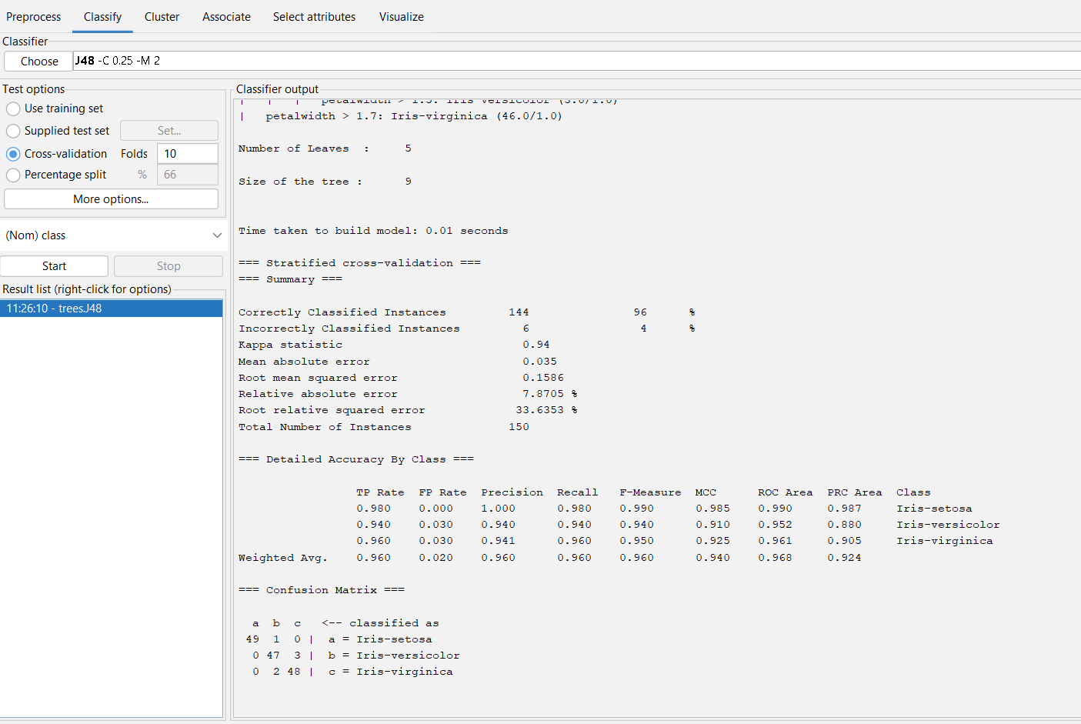

OUTPUT INFORMAATION OF IRIS IN ACCURACY FINDING.

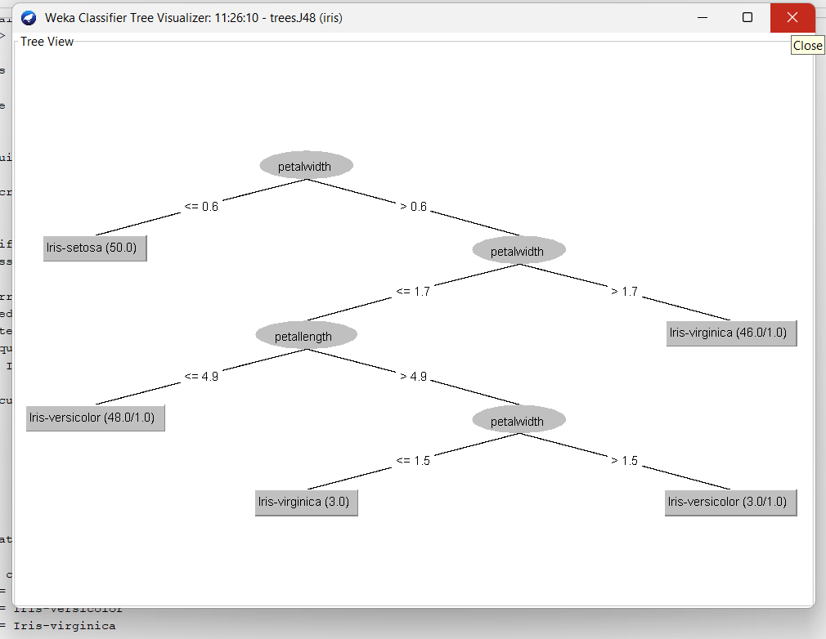

TREE DIAGRAM OF ACCURACY WITH IRIS INFO IN WEKA

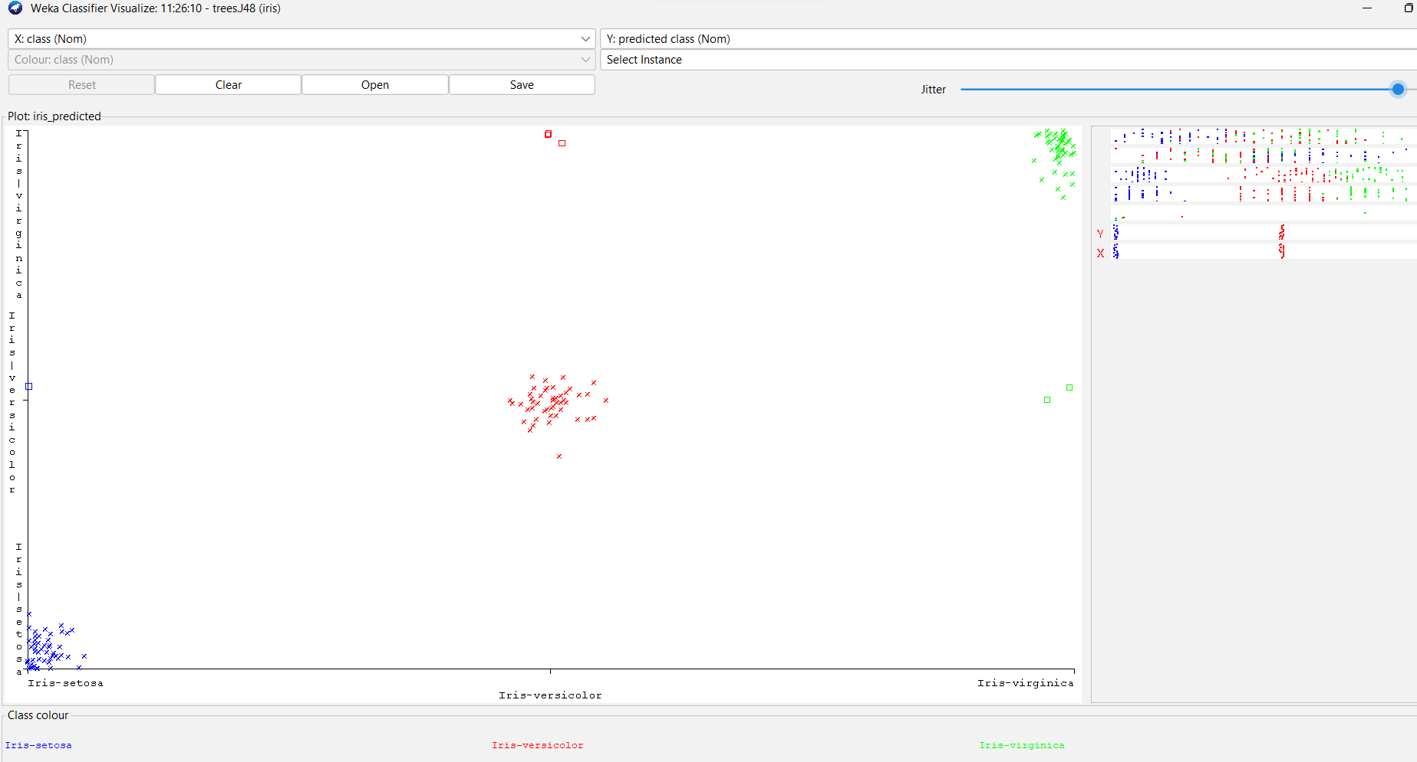

ERROR ACCURACY RATE OF IRIS IN WEKA.